Monthly Media Report
December 2009

JAN

FEB

MAR

DEC

NOV

MAY

APR

JUN

JULY

AUG

SEPT

OCT

Table of Contents

December 23, 2009 Students Devise Plan to Cut Overspending, Emirates Business 24/7

December 22, 2009 Barclays Bank Encourages Innovation and Entrepreneurship Among the
Youth Through the Launch of the ‘You Can B!’ Innovation, AmeInfo

December 3, 2009 Great ideas From Young Guns, Khaleej Times

Publication: Al Arab
Language: Arabic
Country: Qatar
Circulation: 22,000
Date: October 21, 2009

For the first time in the UAE, Barclays and INJAZ-UAE, a member of Junior Achievement (JA) Worldwide, have partnered to encourage innovative and creating thinking among 15 to 18 year old students through the 'You can b! Innovation Day Camp starting on 22nd December 2009. This day camp is part of the Barclays and JA Worldwide 'You can b! initiative, a three-year, AED 10,980,000 initiative that will support the expansion of JA Worldwide's® JA Company Program® and JA Job Shadow™ to reach a projected 8,000 students in 11 countries during its first year. In addition to the United Arab Emirates, targeted countries include Botswana, Ghana, Kenya, Tanzania. Uganda, Zambia, Zimbabwe, Russia, Egypt and India.

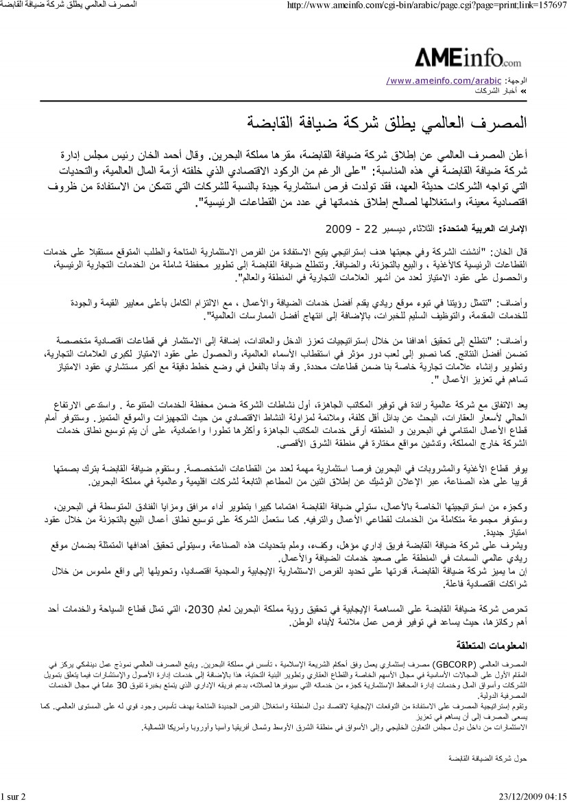

Publication: Khaleej Times
Language: English
Country: UAE
Date: December 15, 2009

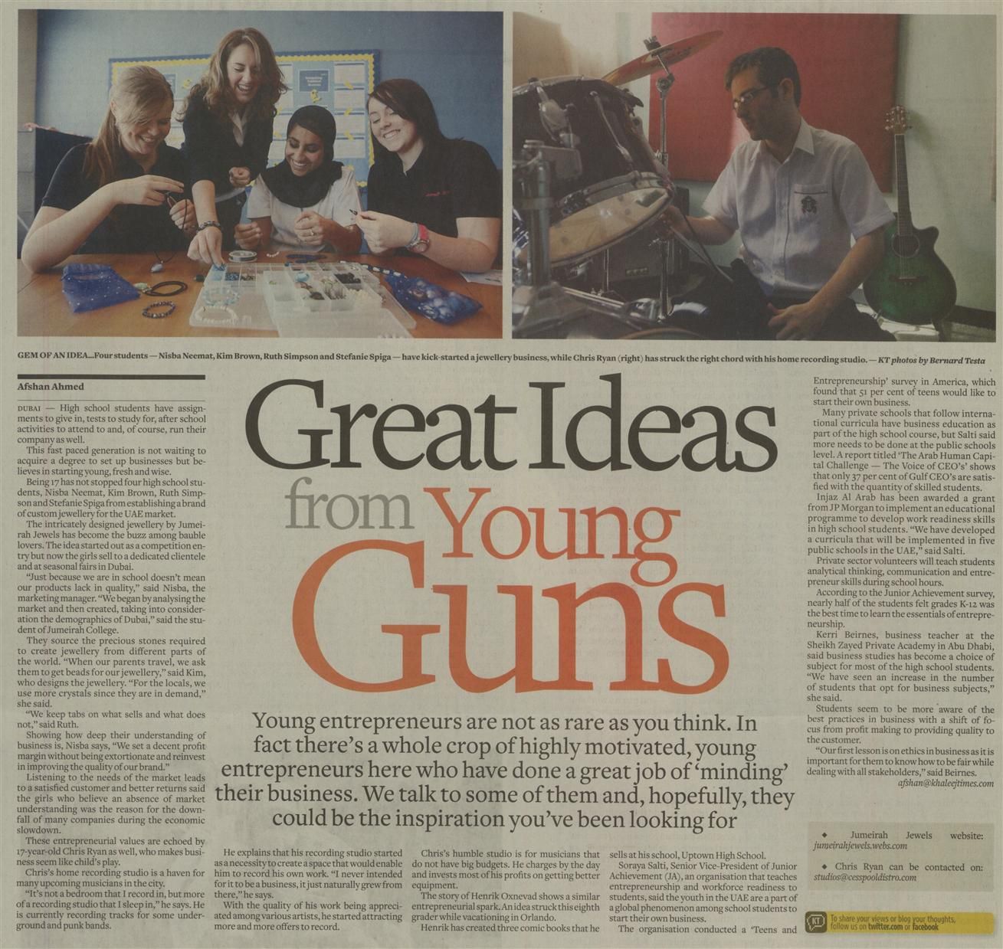

Publication: Emirates Business 24/7
Language: English
Country: UAE
Circulation: 52,000
Date: December 23, 2009

